**How to provide the spring security to spring boot project**

Step-1

Go to pom.xml file and add below maven dependency

<dependency>

<groupId>org.springframework.security</groupId>

<artifactId>spring-security-core</artifactId>

<version>5.6.1</version>

</dependency>

Step-2

In application.properties file, need to add below two lines

spring.security.user.name = jeevan

spring.security.user.password = pune1234

Step-3-

Open the postman tool, click on Authorization tab->Select API key in the Type field then write Jeevan as key and value as pune1234 as attached in the screenshot below

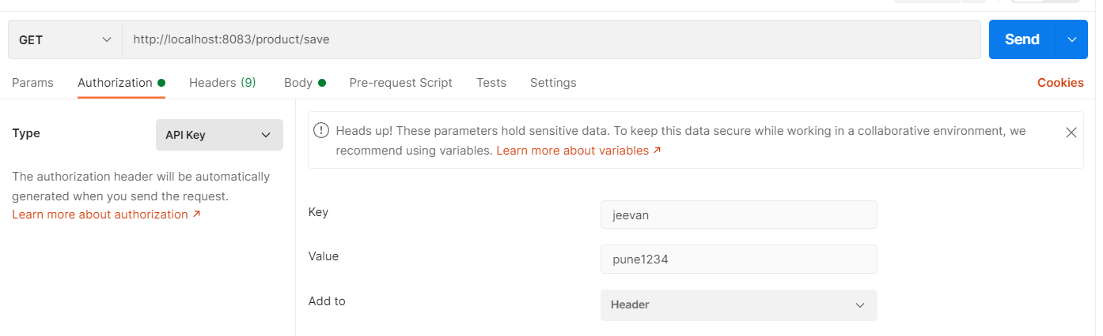

Step-4 Enter any url and click on send button